Experiment No.1

Name of the Experiment: Data Preparation using NumPy and Pandas.
Aim: a. To derive an index field and add it to the dataset.
- To identify and analyze the missing values in the dataset.
- To obtain a list of all records that are outliers with respect to any selected field.
- To display the top 10 largest values for the selected field.
- To standardize the selected variable.
- To identify the total number of outliers and determine the most extreme outlier.
Requirements: Python 3.x with NumPy, Pandas, Matplotlib and Seaborn libraries installed, along with Google Colab or Jupyter Notebook environment and a stable internet connection.
Pre-requisites: Basic knowledge of Python programming, understanding of arrays and data frames, and familiarity with basic statistical concepts such as mean, standard deviation and outliers.
Theory: Data preparation is a crucial step in data analysis and data mining, as raw data collected from real-world sources is often incomplete, inconsistent, and contains noise or outliers. Before applying any analytical or machine learning techniques, the dataset must be cleaned, structured, and transformed into a suitable format. In this experiment, Python libraries such as NumPy, Pandas, Matplotlib, and Seaborn are used for data preparation and exploratory data analysis.
NumPy (Numerical Python) is an open-source library that provides support for large, multi-dimensional arrays and matrices, along with a collection of high-level mathematical
functions to operate on these arrays. NumPy arrays are faster and more memory-efficient than Python lists and are widely used for numerical computations, matrix operations, and statistical analysis.
Pandas is a powerful open-source Python library built on top of NumPy, designed for data manipulation and analysis. It provides flexible data structures such as Series (one-dimensional) and DataFrame (two-dimensional), which make it easy to store, manipulate, and analyze structured data. Pandas allows easy handling of missing values, indexing, slicing, filtering, aggregation, and transformation of data.
An index field is an essential component of a dataset, as it uniquely identifies each record.
Pandas automatically provides an index, but custom index fields can also be derived and added to improve data traceability and organization.

Missing values are common in datasets and may occur due to data collection errors or
incomplete records. Pandas provides built-in functions such as isnull() and notnull() to detect missing values, enabling proper handling through removal or imputation.
Outliers are data points that significantly differ from other observations in the dataset. They may occur due to measurement errors, data entry mistakes, or genuine variability in the data.
Identifying outliers is important because they can heavily influence statistical analysis and model performance. In this experiment, outliers are detected using graphical methods such as histograms, scatter plots, box plots, and distribution plots.
- Histograms help visualize the distribution of a single variable and identify skewness or extreme values.
- Scatter plots are used to examine relationships between two numerical variables and detect abnormal patterns.
- Box plots provide a clear visual representation of median, quartiles, and outliers using the interquartile range (IQR) method.
- Distribution plots (distplots) help analyze the probability density and spread of data.
Standardization is a data transformation technique used to rescale variables so that they have a mean of zero and a standard deviation of one. This process is useful when comparing variables measured on different scales and is essential for accurate outlier detection.
By identifying the number of outliers and determining the most extreme outlier, this experiment demonstrates the importance of data preprocessing in ensuring reliable and meaningful analysis. Visualization tools combined with Pandas operations provide an efficient and intuitive approach to understanding data behavior.
NumPy is a fundamental Python library used for numerical and scientific computing. It provides support for large, multi-dimensional arrays and matrices along with a wide collection of mathematical, statistical, and linear algebra functions. NumPy performs operations much faster than normal Python lists because it uses optimized C-based implementations and efficient memory management. It allows easy creation and manipulation of arrays, matrix operations, statistical calculations, and data standardization, which are essential steps in data preprocessing. Due to its speed, accuracy, and efficient memory usage, NumPy is widely used in data exploration, scientific research, and machine learning applications.
Pandas is a high-level data analysis and data manipulation library built on top of NumPy. It provides powerful data structures such as Series and DataFrames that make it easy to handle
structured and tabular data. Pandas simplifies data loading from various file formats like CSV, Excel, and databases, and offers built-in functions for handling missing values, removing duplicates, filtering data, and performing aggregations. It enables quick exploratory data analysis through descriptive statistics and data summarization. Pandas integrates smoothly with

visualization and machine learning libraries, making it an essential tool for data preparation, exploration, and analysis in data mining and business intelligence.

Comparison Parameter | Pandas | NumPy
Primary Use Case | Data analysis, data cleaning, and manipulation of structured data. | Numerical and scientific computing, matrix operations, linear algebra.
Core Data Structure | DataFrame (2D table) and Series (1D labeled array). | ndarray (n-dimensional array).
Data Types | Handles heterogeneous data types (e.g., int, string, float) within different columns of a DataFrame. | Stores homogeneous data types (all elements must be the same type).
Indexing | Uses both integer and label-based indexing, which can be slower due to the overhead of label management. | Uses only integer-based position indexing, which is generally faster.
Performance | Slower for raw numerical calculations but performs well with large datasets and complex data manipulation tasks (e.g., grouping, merging). | Faster for numerical operations, especially on smaller datasets or for specific matrix calculations.
Memory Usage | Consumes more memory due to the added features like indexing and support for varied data types. | More memory efficient.
Missing Data | Built-in functionality for handling missing data (NaN). | Limited built-in support for missing data.

- Creating a BASIC DATAFRAME (Pandas)-
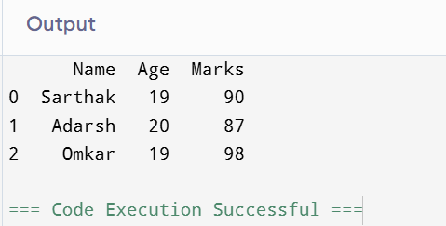
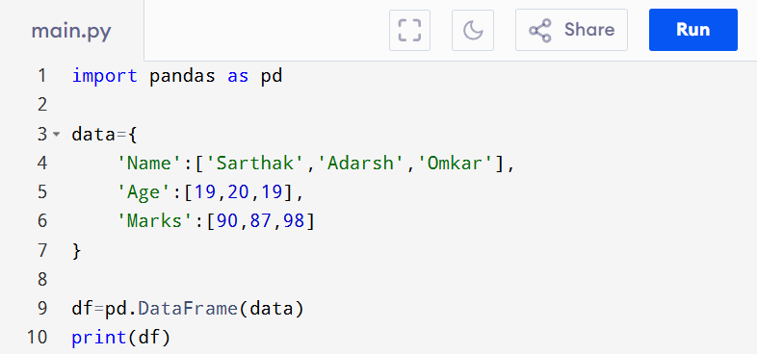

- Using List of Lists-
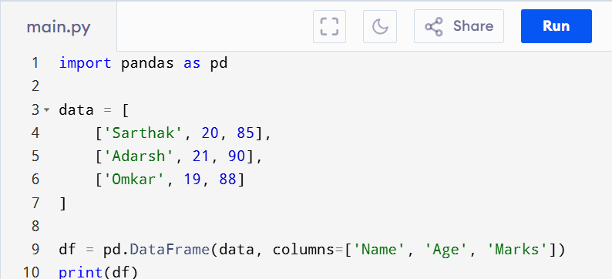

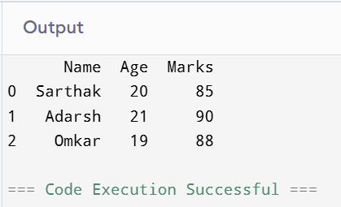

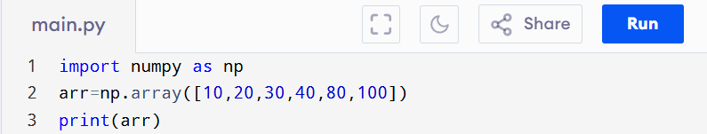
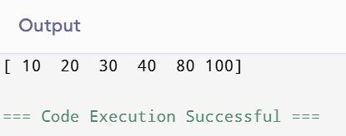
- NUMPY ARRAY/ Single & Multi-Dimensional Array-

- Multi-Dimensional Array

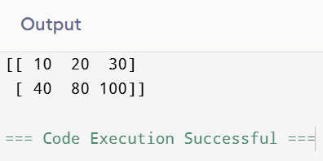
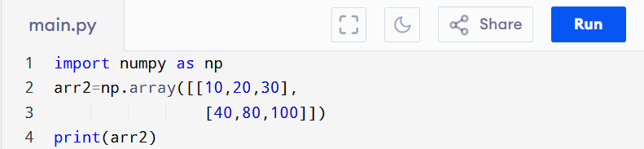
- Creating Data Frame from Dictionary-

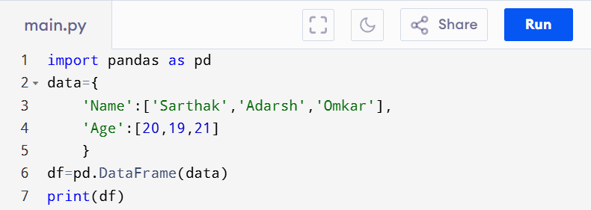
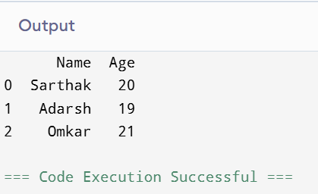

- Creating DataFrame from a List-

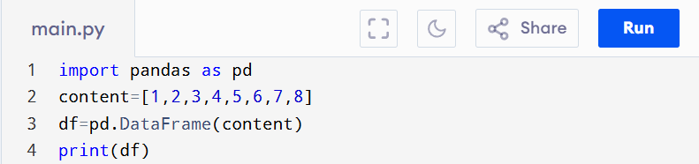
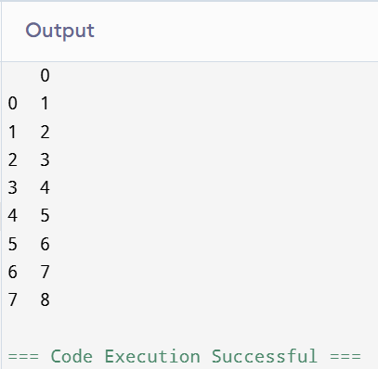

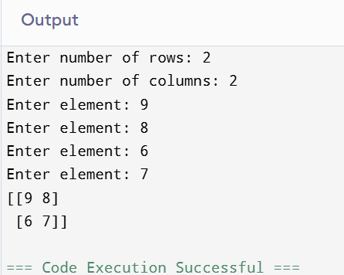
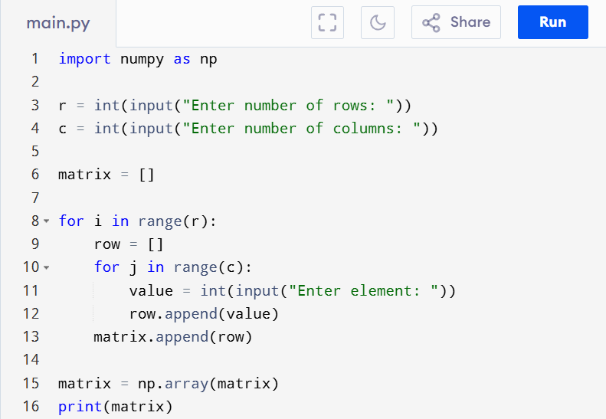
- Inputing Data-

- Load Required Libraries & Dataset-
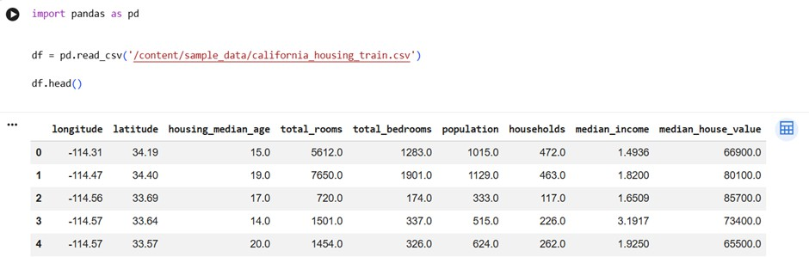

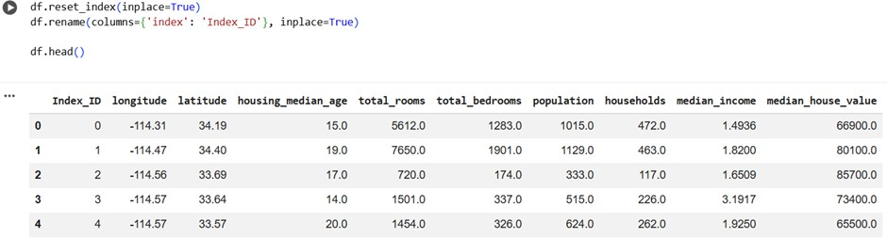
- Derive an Index Field and Add it to the Dataset-

- Find Out the Missing Values-
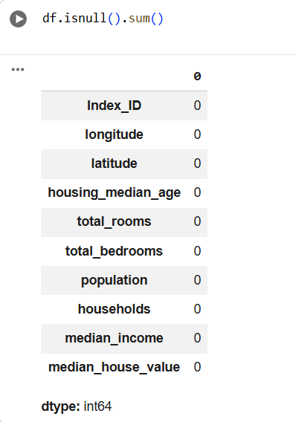

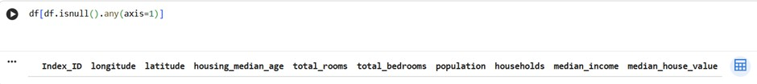
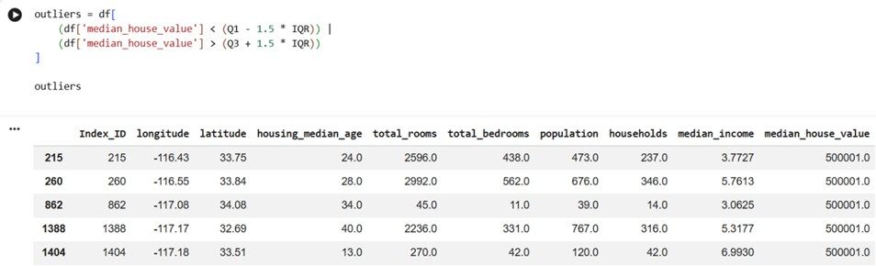
- Obtain Listing of Outliers-
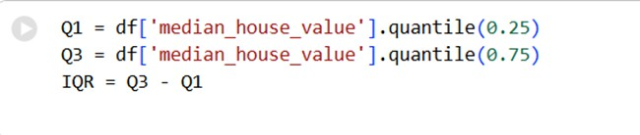

- Print Listing of 10 Largest Values for that Field-
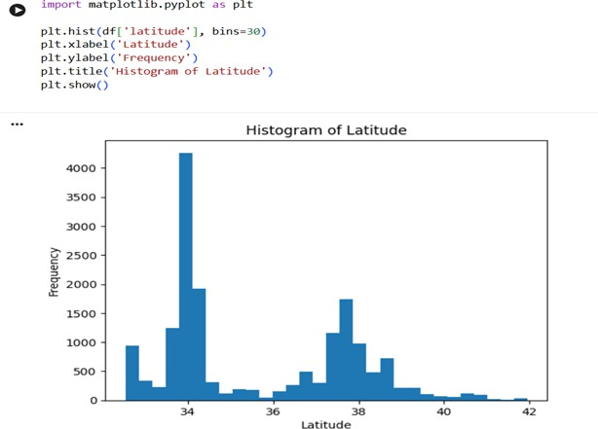

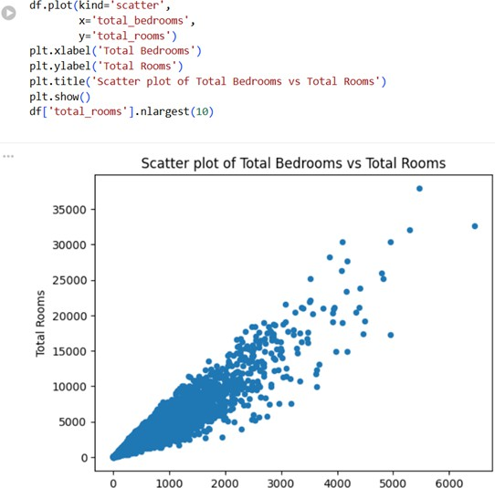
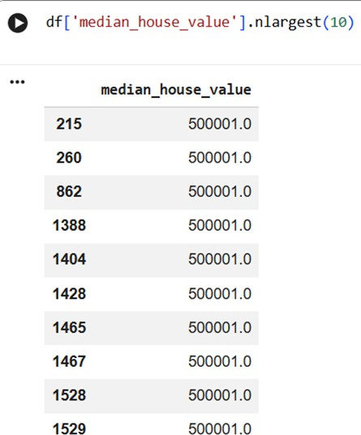

- Standardize the Variable-
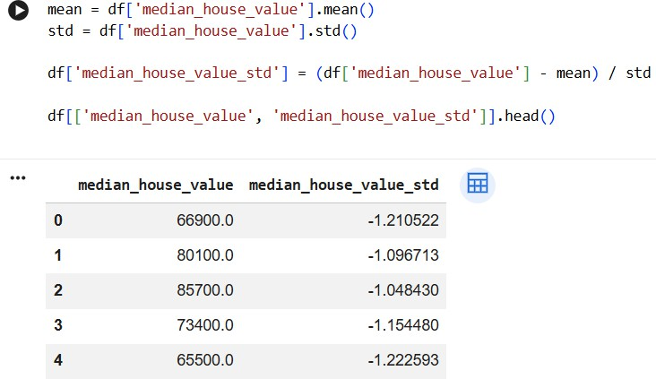

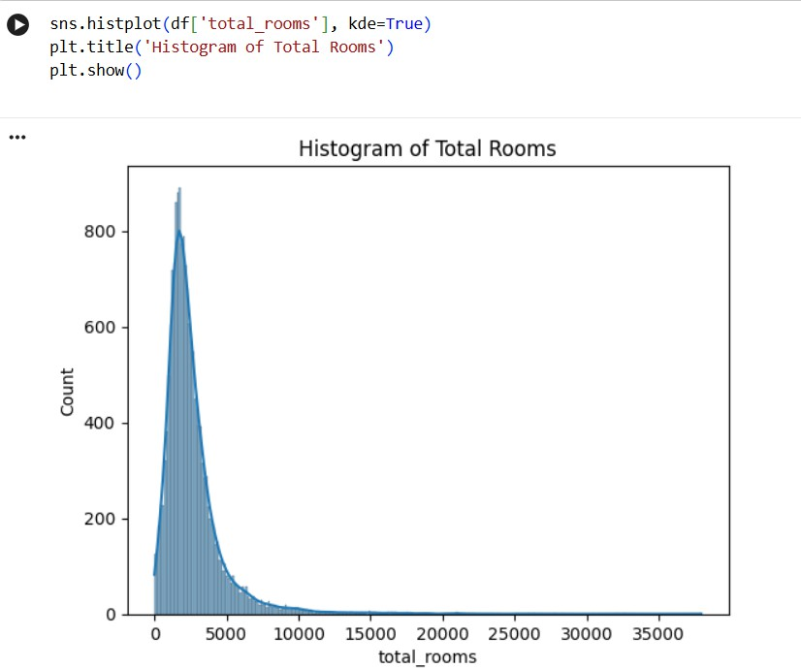
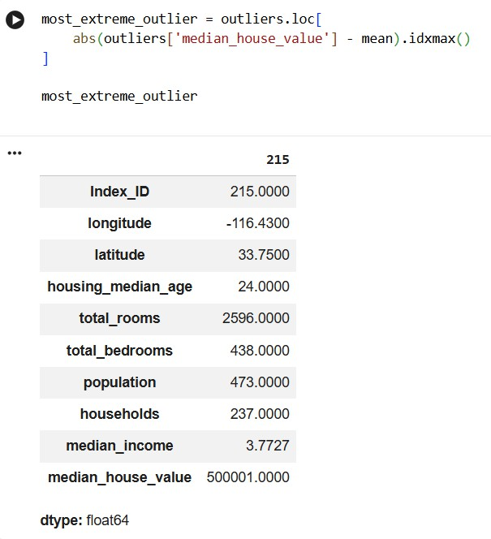

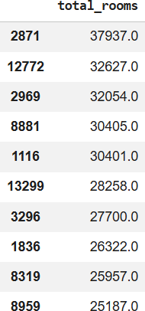

Most_extreme_outlier
- Identify Number of Outliers & Most Extreme Outlier-
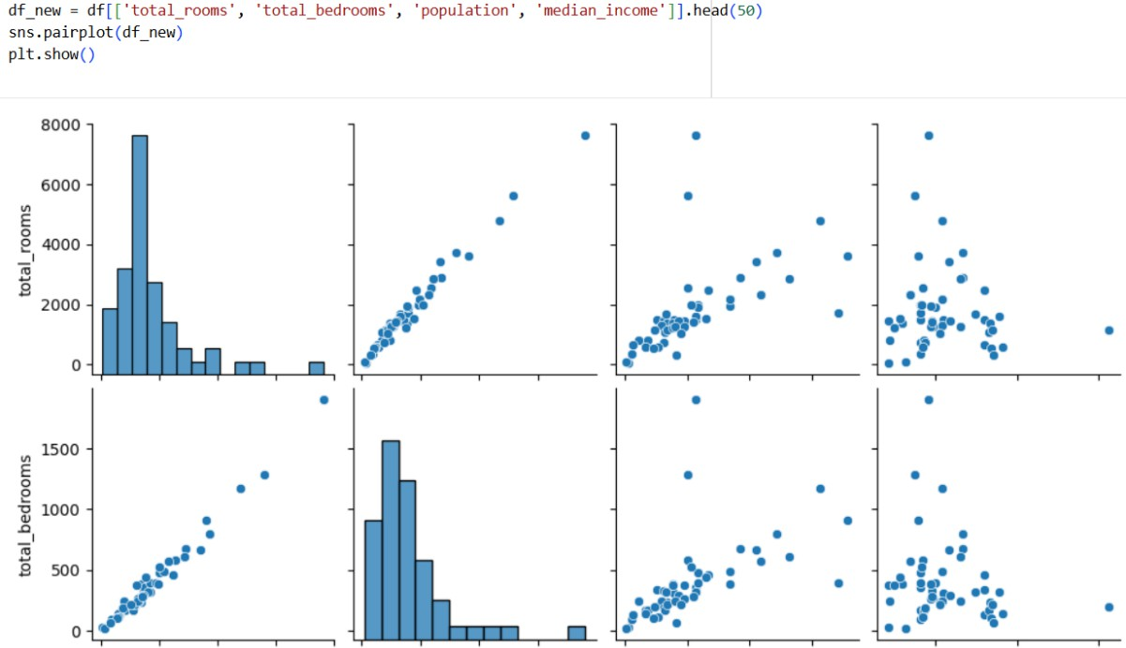
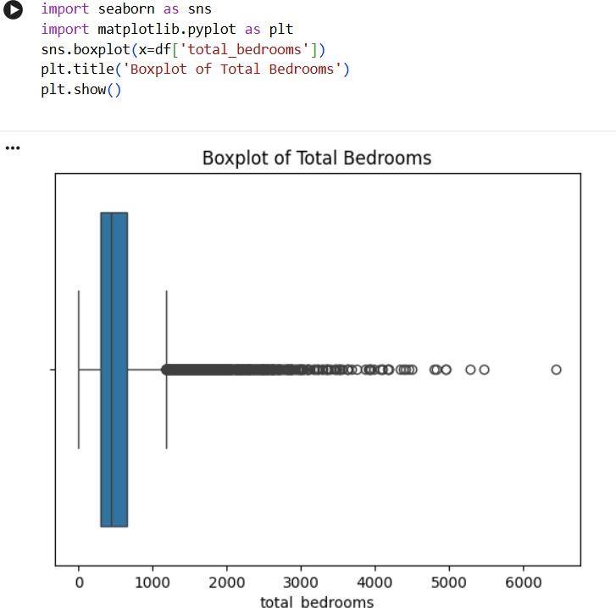

Conclusion: For the above AIDS experiment the dataset used is california_housing_test.csv. With help of Google Colab platform it’s very easy to perform Data Science algorithm. Use of online storage like Google Drive in Colab has increased availability of the dataset for all the time. Numpy and Pandas library for variety of tasks on california_housing_test.csv has been studied successfully.

